Zomazon Case Study

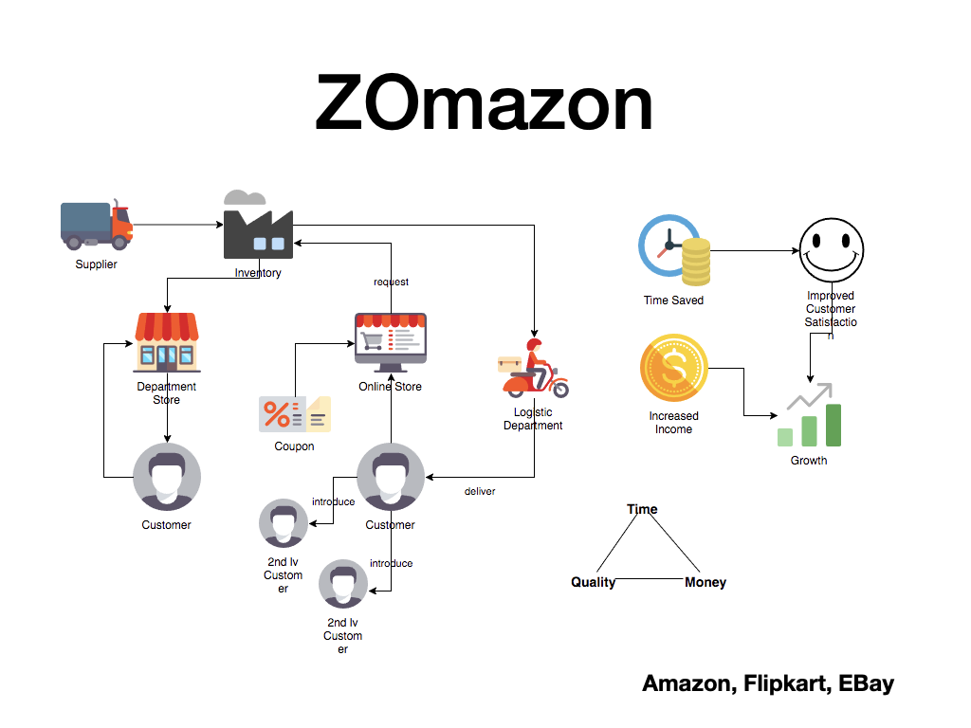

Functional Requirements

Sellers should be able to add, delete and modify products they want to sell.

The website should include a catalog of products.

Buyers can search products by name, keyword or category.

Buyers can add, delete or update items in a cart.

Buyers can purchase items in the cart and make payments.

Buyers can view their previous orders.

Buyers can review and rate purchased products.

Non-Functional requirements\

Availability: 99.95%

High Consistency: How to achieve in a distributed system?

Low Latency: Response time: < 250 ms